- Create a visual timeline (using Canva, Google Slides, or any online tool) that shows the major Google algorithm updates: Panda, Penguin, Hummingbird, RankBrain, BERT, and MUM, including the year and a one-line impact summary for each

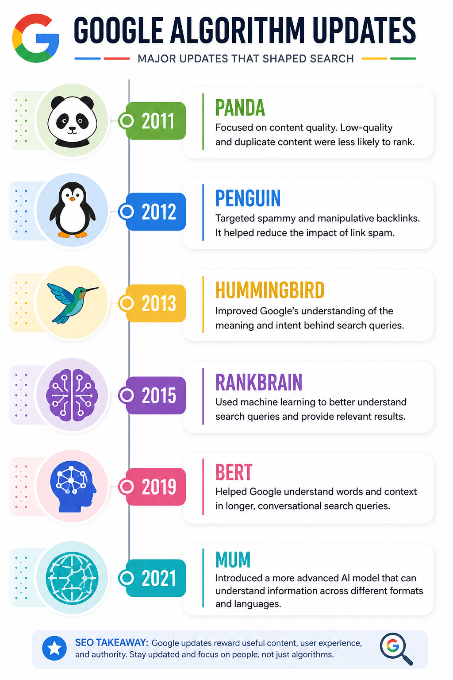
- Pick any one Instagram Reel or YouTube Short you recently watched and write a short analysis (100-150 words) on how Google’s BERT or RankBrain algorithm might help users discover similar content via search.

Example: Instagram Reel – “SEO Tips for Beginners”

I recently watched an Instagram Reel about “SEO Tips for Beginners.” After watching it, I wanted to learn more about SEO. So, I searched on Google for “How to learn SEO for beginners.” BERT helps Google understand what I really mean, while RankBrain helps Google find useful and relevant results. Because of this, Google can show me helpful blogs, videos, and websites related to SEO. In simple words, BERT helps Google understand my search, and RankBrain helps find the right results for me. This makes my search easier and saves me time.

- Research the new SGE (Search Generative Experience) feature by Google and write a step-by-step guide showing how a user’s search journey changes compared to classic Google Search.<br><br><em><strong>Hint:</strong> Focus on how AI-generated summaries and follow-up questions appear for a search like 'best budget smartphones in India'.</em>
Best budget smartphones in India
Step 1: You type your question on Google.
Step 2: Google shows an AI answer/summary at the top.
Step 3: You quickly get information about good phones, prices, and features.
Step 4: You can ask another question, like “Which is best for gaming?”
Step 5: Google gives you another answer.

Simple Difference
Old Google: Search → Open websites → Read → Compare
AI Search: Search → AI gives answer → Ask another question → Get more answers
In one line:
👉 AI Search saves time by giving a quick answer and letting you ask follow-up questions.

- Imagine you are optimizing a Zomato restaurant page for GEO (Generative Engine Optimization). List 3 specific content or technical changes you would make so the restaurant appears in AI-generated search answers, and explain why each change matters.
Change | What I would do | Why it helps
Add clear information | Add the restaurant's name, location, cuisine, price, timings, popular dishes, and special features. | AI can easily understand the restaurant and give accurate answers.
Add FAQs | Add questions like “Is this restaurant good for families?”, “What are the best dishes?”, and “Is home delivery available?” | AI can use these clear answers when users ask similar questions.
Use reviews and structured data | Show genuine customer reviews, ratings, menu details, and proper structured information. | This gives AI more reliable information about the restaurant.
- Use ChatGPT or Google Bard to simulate a 'training bot' scenario: Ask the AI how it would rank a new Flipkart product page for the keyword 'wireless earbuds under 2000'. Copy-paste the AI’s response and write 2 ways you could improve the page based on its suggestions.<br><br><em><strong>Constraint:</strong> Your improvements must be actionable (e.g., add user reviews, optimize product description).</em>

Prompt given to AI:
“How would you rank a new Flipkart product page for the keyword ‘wireless earbuds under 2000’? Explain the important SEO factors you would consider.”
AI Response:
To rank a new Flipkart product page for “wireless earbuds under 2000,” I would focus on keyword relevance, product information, user experience, reviews, and technical SEO.
- Keyword optimization: Use the target keyword naturally in the product title, description, headings, URL, image alt text, and relevant product attributes.
- Detailed product description: Include important information such as price, battery life, sound quality, connectivity, warranty, and key features. Avoid keyword stuffing.
- User reviews and ratings: Genuine customer reviews, ratings, and detailed feedback can improve trust and provide useful user-generated content.
- Product images: Use high-quality images with descriptive alt text showing the earbuds from different angles.
- Page experience: Make the page mobile-friendly, fast-loading, easy to navigate, and clear about price, offers, delivery, and availability.
- Product comparisons: Adding comparisons with similar earbuds under ₹2,000 can help users make a decision and increase the usefulness of the page.
- Internal linking: Link the product page from relevant Flipkart category pages, such as wireless earbuds and audio accessories.

2 Actionable Improvements
1. Add more user-generated reviews
Add genuine customer reviews with ratings, photos/videos, and specific feedback about sound quality, battery life, comfort, and microphone performance. This will make the product page more trustworthy and useful.
2. Optimize the product description
Rewrite the description to naturally include “wireless earbuds under 2000” and related terms such as Bluetooth earbuds under ₹2,000, budget wireless earbuds, long battery life earbuds, while clearly explaining features, specifications, warranty, and benefits

